The goal of this project is to find the correlation between the prevalence of certain diseases and the number of pharmacies in counties all over the United States. The diseases for which we find correlation are: Obesity, Hypertension, Diabetes, CVD, HIV/AIDS, CVD (per 100K) and Hypertension (per 100K).

In the following correlation matrix, we can observe the correlation between different diseases and the number of pharmacies in a county.

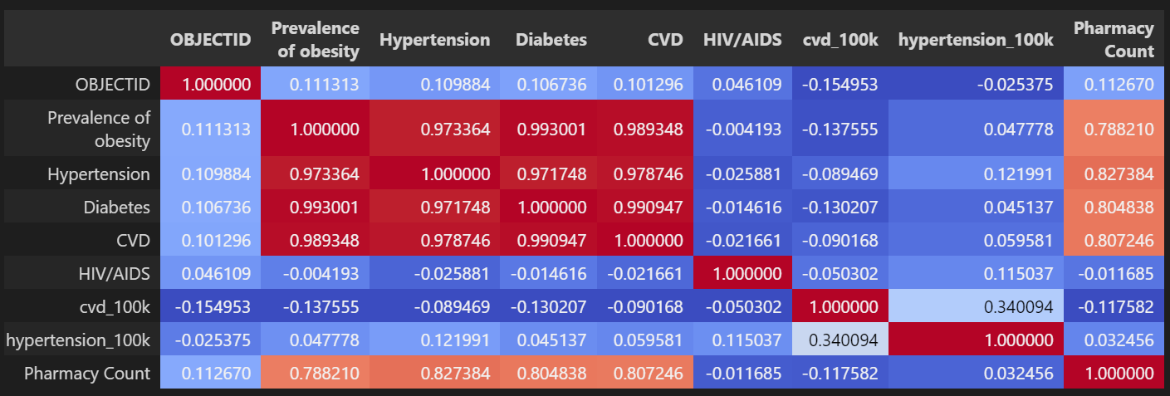

Hence, we can see that Obesity, Hypertension, Diabetes, and CVD has a string positive correlation with the number of pharmacies in that county. HIV/AIDS, CVD (per 100K) and Hypertension (per 100K) have a low correlation with the number of pharmacies.

This can be further seen in the following heat map:

We can also inspect scatterplots to observe the correlation.

Obesity, Hypertension, Diabetes, and CVD has a string positive correlation with the number of pharmacies in that county:

Whereas, HIV/AIDS, CVD (per 100K) and Hypertension (per 100K) have a low correlation with the number of pharmacies:

